During comp move :
1^{s}st all the keys present in the ic will be appended to list consisiting of moves 1-9
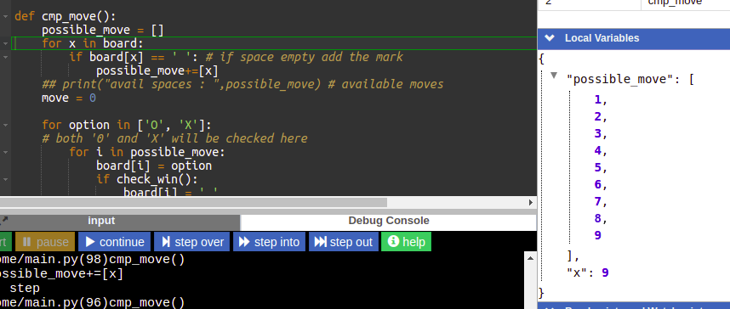
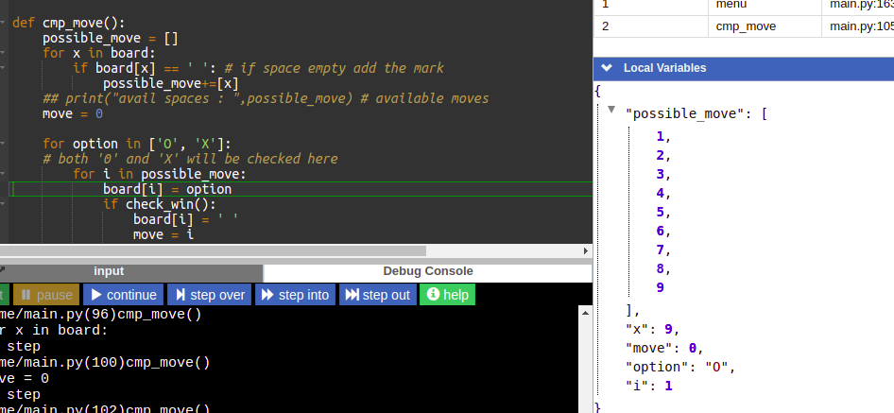

At first the number of move = 0
option will consist of mark “0” for comp move

